Survival Instinct Game Engine
My PBL is about a game I am making using the Unity Game Engine. The game is called Survival Instinct. It is a game where you have to survive a few nights in the wilderness with animals and enemys such as zombies and more. The game is currently incomplete but I will put a link to Survival Instinct once I finish it.
Gui Interface | Different Views
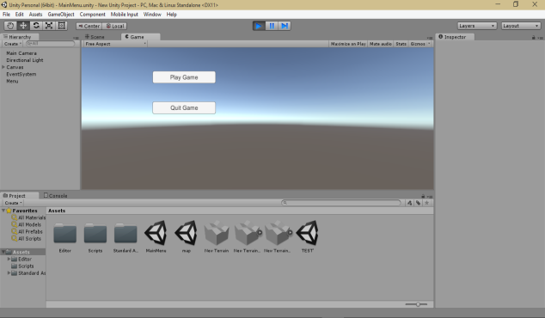 | 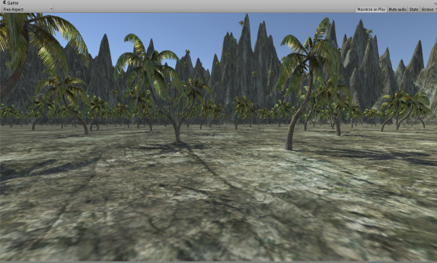
Forest View | Android Game
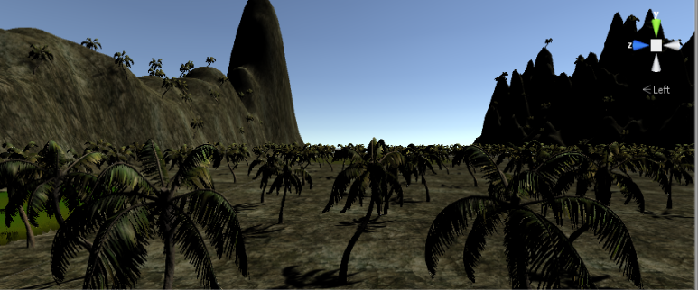

So You Want to be a Game Designer
Watch my tutorials and learn how to use Survival Instinct Game Engine. It is simple to design and programming using the C# language.
Why did I choose this software?
I chose this software because it is very simple but very powerful for game design.
How to use this?
You use this by programming and a few other prospect such as 3d modeling and level design.
What did I learn?
I learned how to make a basic survival game while teaching others how to do it as well.
My Video | My Website

